Wire Mesh Mist Eliminator
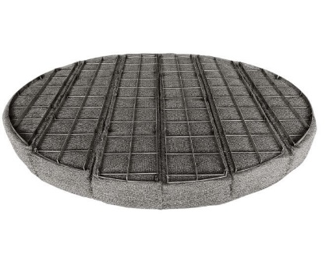
Arabo manufactures high-performance knitted wire mesh mist eliminators alongside our pall rings, providing a fully integrated, customized separation package tailored to your process needs.
Our knitted mesh demister pads are precision-engineered in stainless steel 304 and 316, delivering exceptional separation of droplets down to 2–5 µm. The multi-layer, high-void (> 95 %) mesh structure maximizes impaction and coalescence while maintaining low pressure drop (< 2 mbar). Ideal for gas-liquid streams up to 300 °C, our pads are available in thicknesses from 100 mm to 300 mm, in diameters up to 6 m, with custom sectional assemblies for ease of installation.
- Material options: SS 304 or SS 316, corrosion-resistant for harsh chemical and high-temperature service
- Pad density: 145–190 kg/m³, free volume ≥ 95 %
- Droplet removal: effective for particles as small as 2 µm with > 99 % efficiency
- Typical pressure drop: under 2.5 mbar at design flow rates
- Modular design: sectional pads with rigid support grids for ease of handling and man-way access

Markets/applications section
Refining

Related Products:
Mist Eliminator – Pall rings – Bubble Ca

